Aero Flow Analysis Project
Thermal Fluids Sciences II: Practicum
4/23/2013
Nicholas Rosado, Eric Thompson, Alex Sturm, Jack Kolodziej

Executive Summary

Performance vehicles, especially in racing environments, require finely tuned aerodynamics to gain the edge over their competitors. Designing aerodynamics for performance cars requires skill and experience because a driver’s life could, potentially, be at risk as a result of a poorly designed vehicle and a few seconds off of a race time can be the different between first place and last. The racing teams need skilled engineers to design the aerodynamics of their vehicles. This project was developed to first introduce and then strengthen the aerodynamic design skills of our team members. The goal of the project was to design a vehicle in SolidWorks that matched or beat the Ferrari La Ferrari sports car in drag power and down force (380lb drag, 1100lb down force). These requirements were later amended to match the drag force numbers of the Porsche Carrera (440lb drag). Additionally a three to one down force to drag ratio was sought as a personal benchmark of success. The vehicle designed in this report achieved a down force to drag ratio of 3.38 and a total drag force of 452lbs.

Introduction

The goal of this project is to design a car that boosted the balance between lift force and drag force, optimizing vehicle aerodynamics. A vehicle will be designed in SolidWorks and a simulation of the vehicle’s aerodynamics performance using SolidWorks Flow Simulation will be run. There were some restrictions put on the vehicle and simulation domain in order for consistent, realistic, and repeatable results to be obtained. The vehicle restrictions were as follows: The vehicle must have a drag power at 150 mph no greater than 155 horse power(hp); The vehicle must have a wheelbase of 104.3”, a width of 80”, a length of 185”, and a maximum height of 45”; The vehicle must have a two person passenger compartment that is 50” wide, 35” long, and 35” tall; The vehicle must contain an engine block that is 40” long, 25” tall, and 30” wide. The engine must be placed behind the passenger compartment; The vehicle modeled must have tires with a 28” diameter and 12” width; No part of the vehicle’s body may be closer than 4” to the ground plane except the tires; When viewed from the front, the tires must be placed at the edge of the vehicle’s width. The simulation domain parameters were as follows: The simulation domain must extend one car length in front and two behind the vehicle, as well as one width on each side, and one width above; The simulation domain must have a ground plane, run at a mesh setting of 4, and all turbulent parameters should be left as default. Following the title page and introduction in this report, the team’s design approach can be found. This is followed by:
- Dimensioned images of the car
- Plot of the drag force vs. vehicle velocity
- Plot of the drag coefficient vs. vehicle velocity
- Plot of the drag coefficient vs. Reynolds number
- Plot of the lift force vs. vehicle velocity
- Plot of the lift coefficient vs. vehicle velocity
- Plot of the lift coefficient vs. Reynolds number
- Plot of Lift/Drag ratio vs. vehicle velocity
- Plot vehicle aerodynamic horsepower requirement vs. vehicle velocity
- Table listing the vehicle’s frontal area, drag force, lift force, Coefficient of drag, Coefficient of lift, Lift/Drag ratio
Finally in the report is a conclusion section that reviews our vehicle’s performance.

Design Approach

The design of the vehicle began as a block of material in SolidWorks extruded to the size of the maximum constraints given. Vehicles were then researched to determine a general shape that could be applied to the design. Looking to minimize drag in initial designs, the Volkswagen XL-1 was chosen as a template because of its low drag profile. This shaped was modified to add a rear spoiler and then extrude cut from the base block. Subsequently crude vortex generators on the roof were added to postpone boundary layer separation. A recessed hood was extruded to reduce drag and increase down force in the front of the car. Ground effects were added to reduce pressure on the underside of the car, further increasing down force.
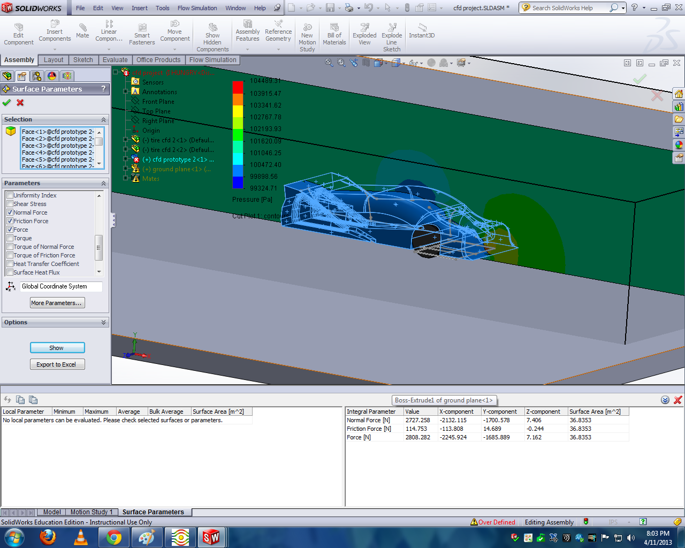
Figure 1: First Design Iteration
A primary flow simulation of the vehicle was run yielding 150 pounds (lbs) of down force and 360lbs of drag on the vehicle. To improve these numbers the team conducted parametric optimization to improve performance. Optimized parameters included: spoiler height; frontal geometries; positioning and shape of vortex generators; and position and shape of ground effects. To increase time efficiency of parametric design, the car was split into two builds, each was optimized separately on two computers. One process focused on shape and geometry of the car front and ground effects while the other focused on vortex generators and the rear spoiler geometry. The original ground effects had been a diffuser of constant 25 degree angle starting from the middle of the car. After studying pressure and vorticity plots from flow simulations, the ground effects diffuser tunnel was redesigned. The diffuser was placed at a 13 degree angle started from the rear of the front wheel-well. Its height then increased at an exponential rate until maximum height at the rear of the vehicle. 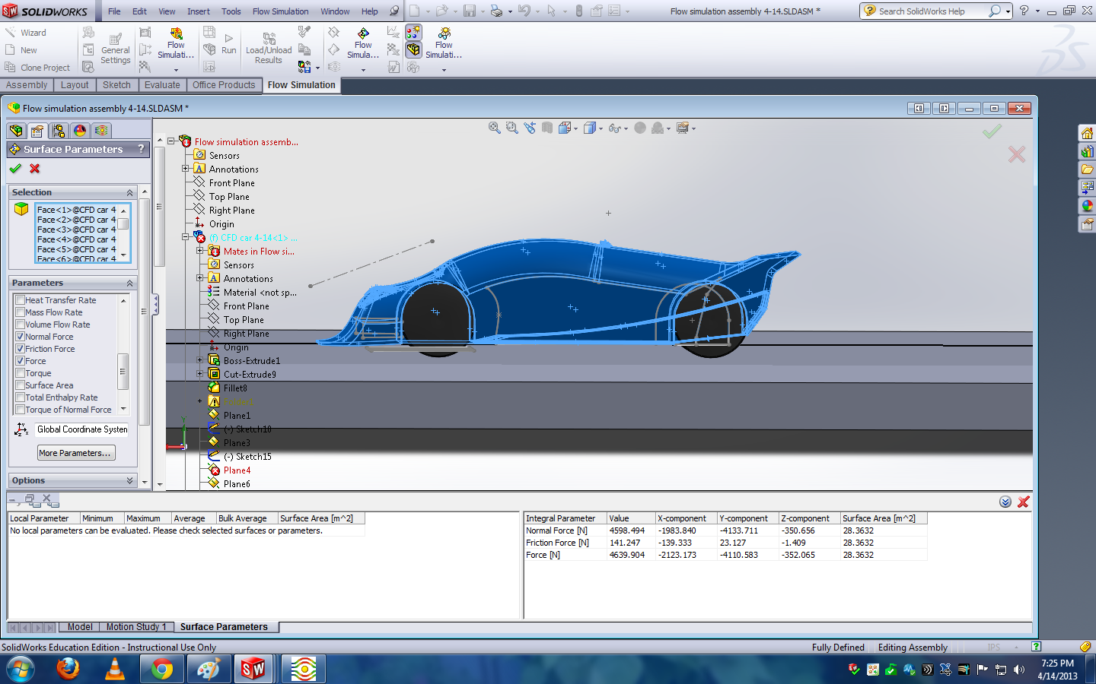
Figure 2: Optimized Ground Effects Angle
Tests with this change yielded lift forces under -1000lbs. Separate simulations determined that the front geometries were too steep and the rear spoiler could be extended over the ground effects to produce a greater pressure differential as seen in the Nissan IMSA-GT. This increased down force to in excess of 1500lbs. Drag at this point was roughly 500lbs. Experimentation continued of the front and rear of the car. In another effort to increase down force, walls were added to the sides of the spoiler.
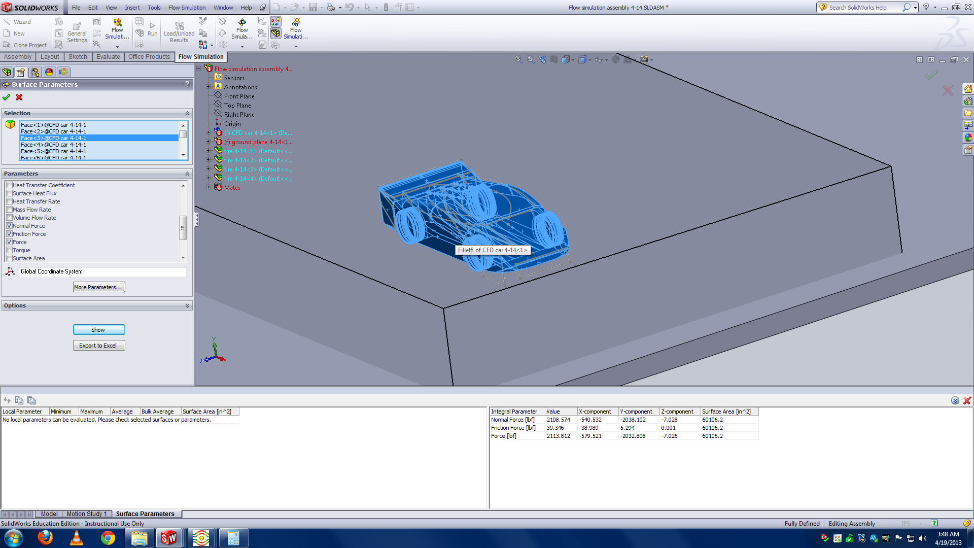
Figure 3: Added Walls to the Back Diffuser
The entire area of the diffuser outlet was encased, separated from the ambient pressure. This addition increased down force to over 2200lbs. At this point highest lift to drag ratios of -3.5 and -3.88 were achieved with the drag approximately 560lbs. To maintain project constraints, drag had to be reduced by over 100lbs. Further analysis of vorticity plots reveals major separation in the wheel-wells. Consequently, all gaps were eliminated between tires and the chassis. This reduced drag to roughly 520 pounds. 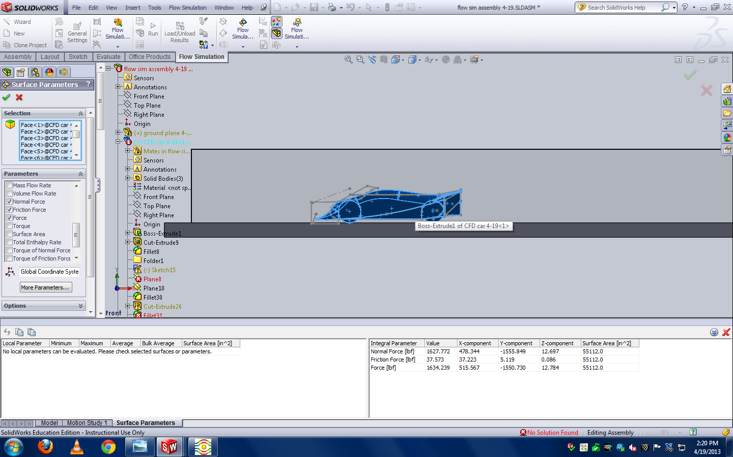
Figure 4: Drag Reduction
Down force dropped to the 1500 to 1800 lbs range. Fillets we added to sharp edges to streamline the car. A further 10-20lbs of drag force were eliminated as a result. Lastly, Tunnels were extruded from the sides of the car, through the spoiler to reduce drag area. This reduced drag a further 30lbs to roughly 470lbs.

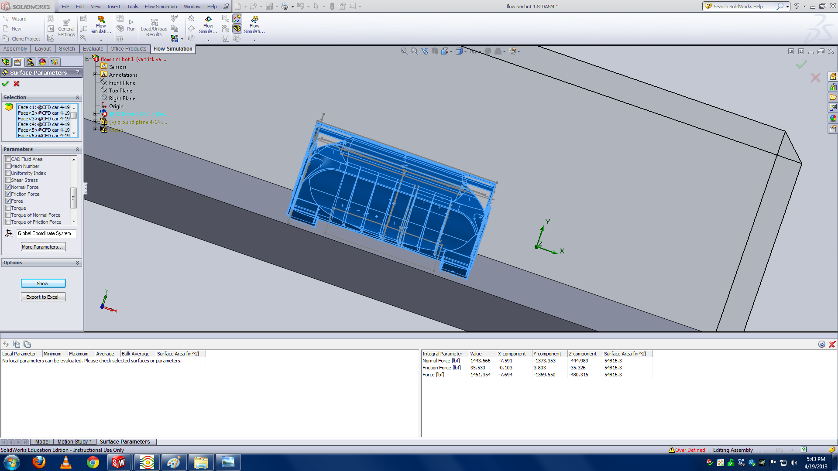
Figure 5: Cuts in the back

The down force after this change was roughly {INSERT HERE}
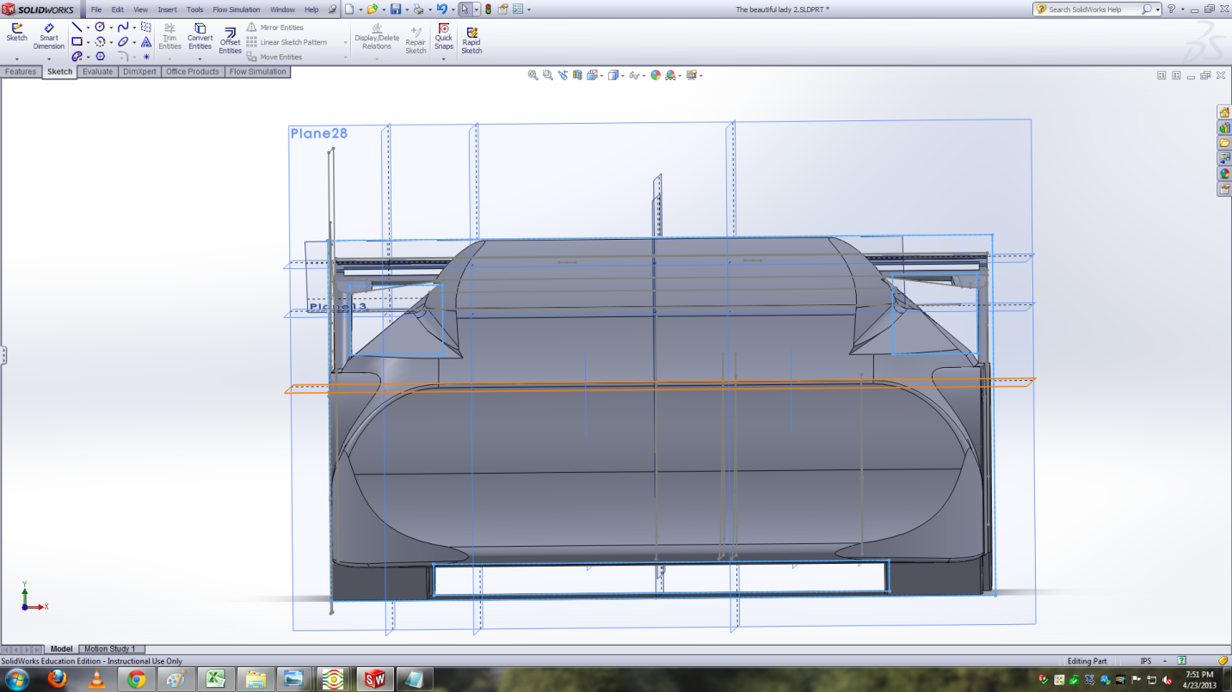
Figure 6: Final Car Front View
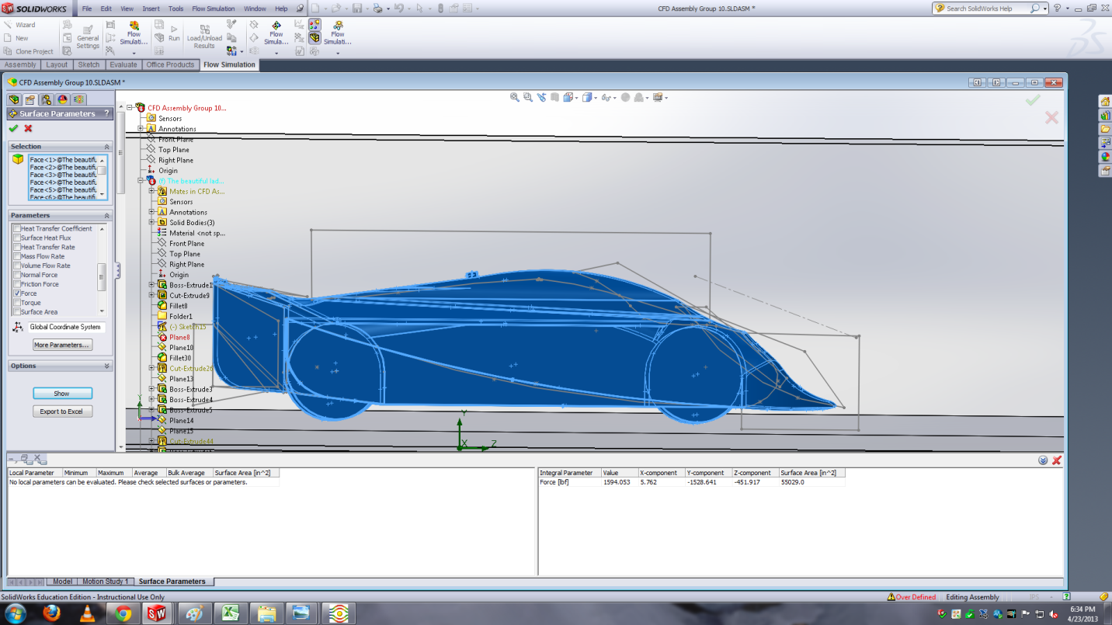
Figure 7: Final Car Side View
Parameters

 | @ 150 mph
Frontal Area | 3315m^2
Drag Force | 452lbs
Lift Force | -1528lbs
Coefficient of Lift
Coefficient of Drag
Lift to Drag Ratio | 3.38

Conclusions

The vehicle designed in this paper met the success criteria. With 1528lbs of down force, it exceeded the down force number of the Ferrari La Ferrarri (1100lbs) and with 452lbs of drag, it only went above the drag force of the Porsche Carrera (440lbs) by three percent. A lift to drag ratio of 3.38 was obtained which met the benchmark of a three to one ratio that the vehicle intended to achieve.

